Giacom Agent-A-Thon Instructions Guide

Step 1: Create a new SharePoint Site
- Build
- Teams Site > Standard Team
- Create a new Document Library
- Upload Excel Sales File
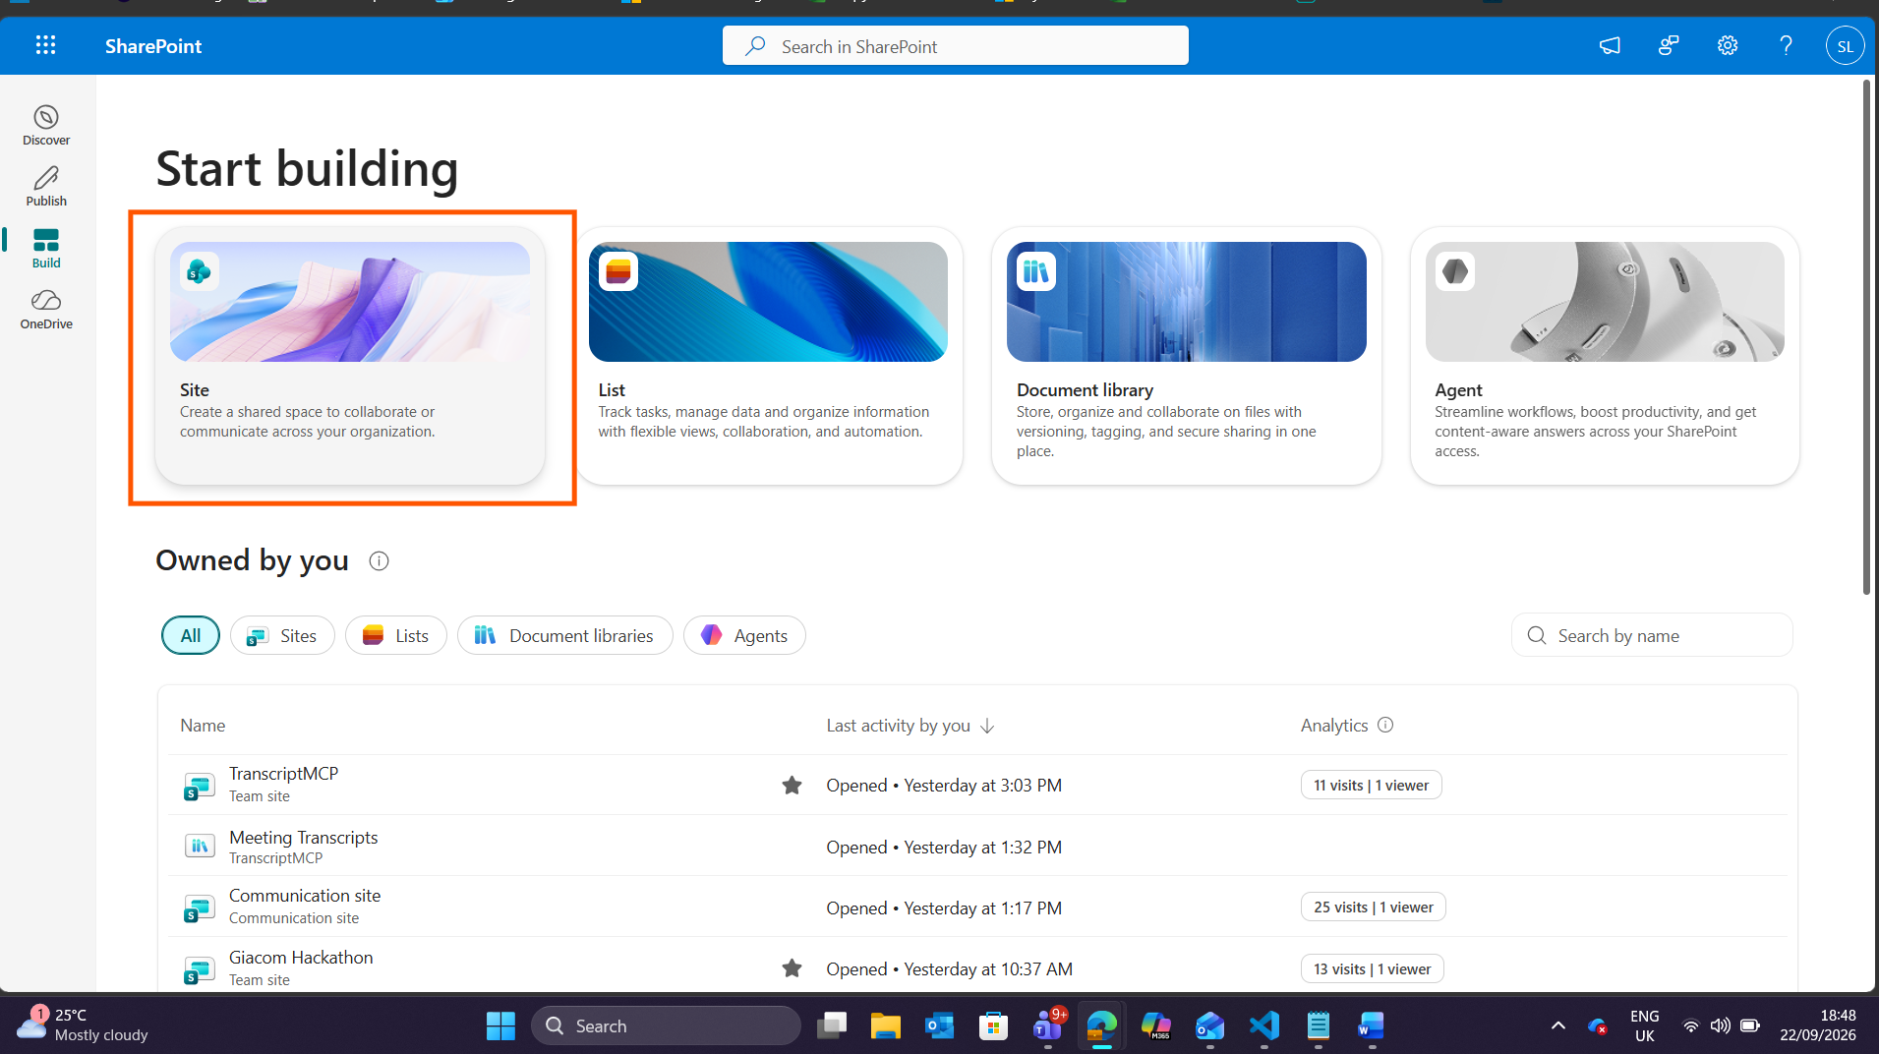
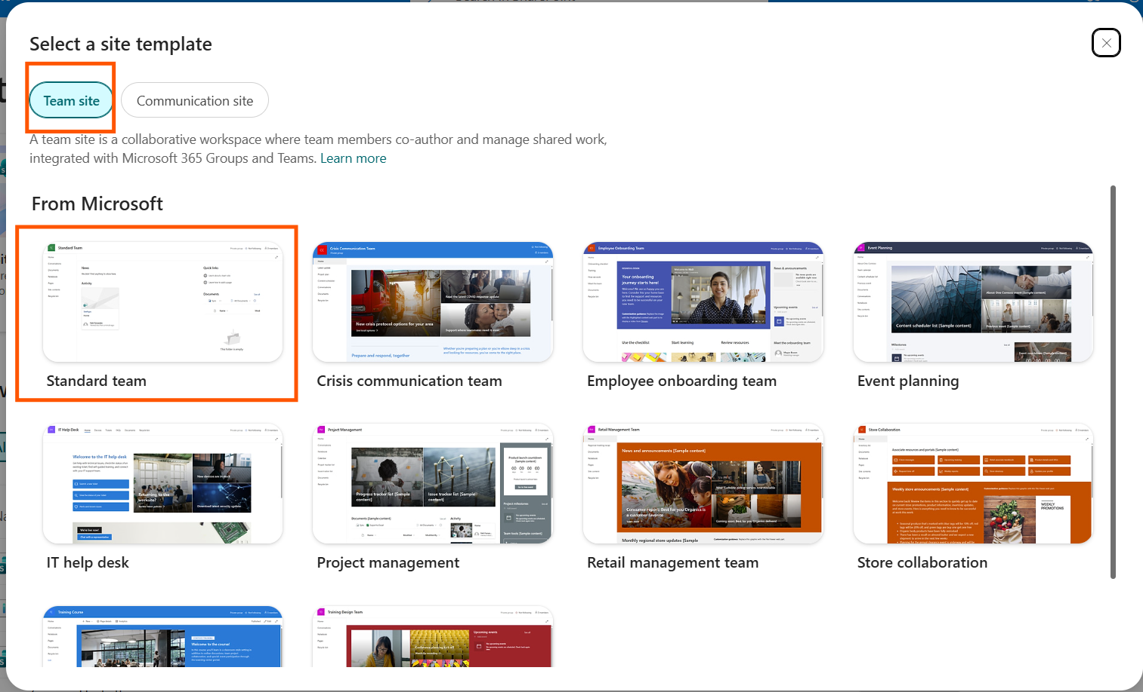

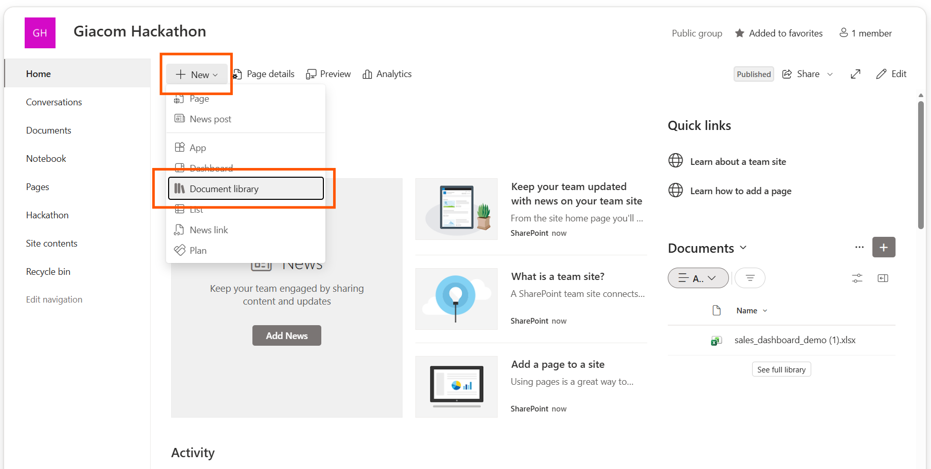
- 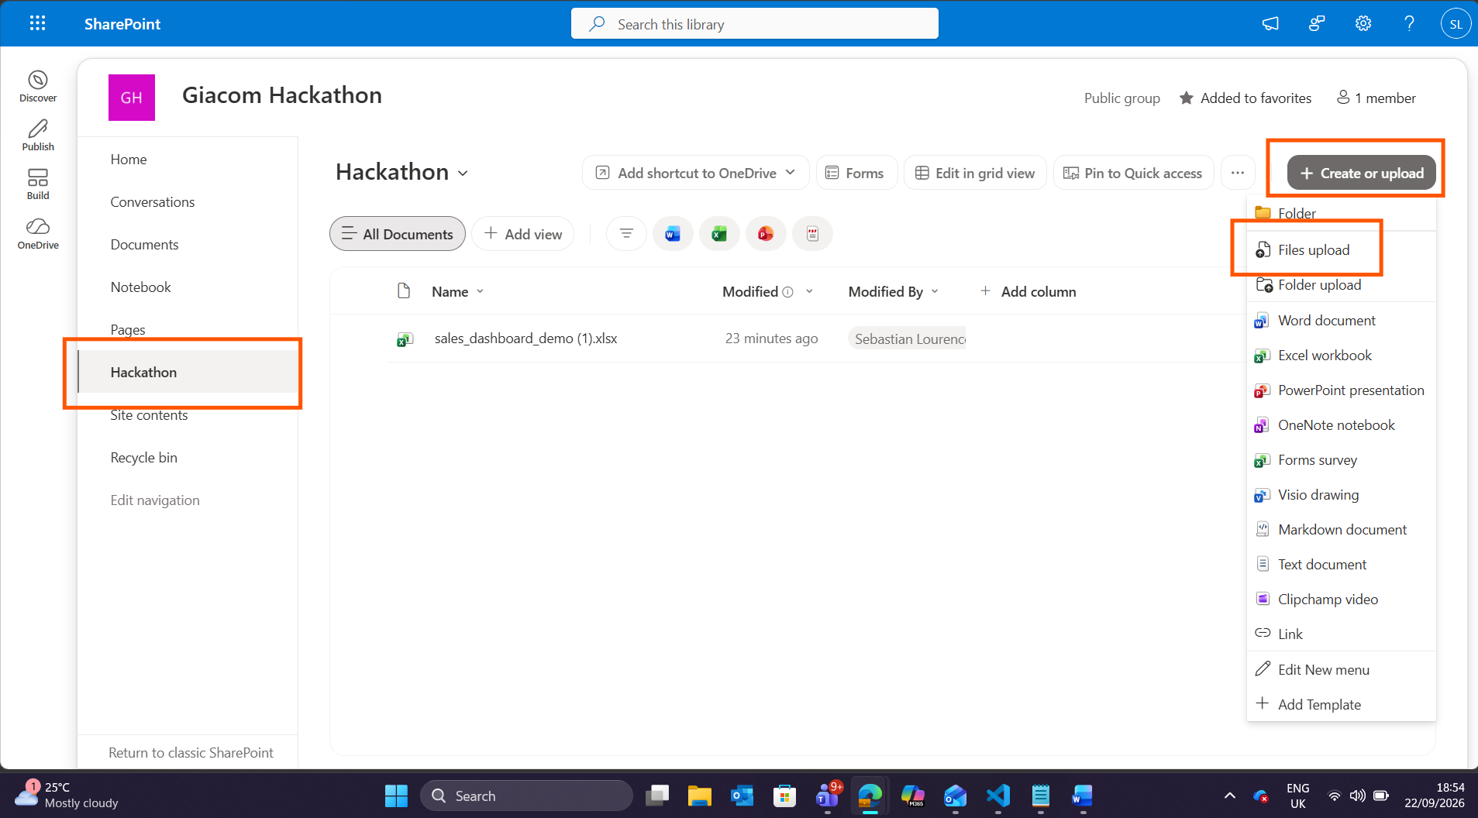
Step 2: Create the Copilot Studio Agent
- Head to the classic Experience
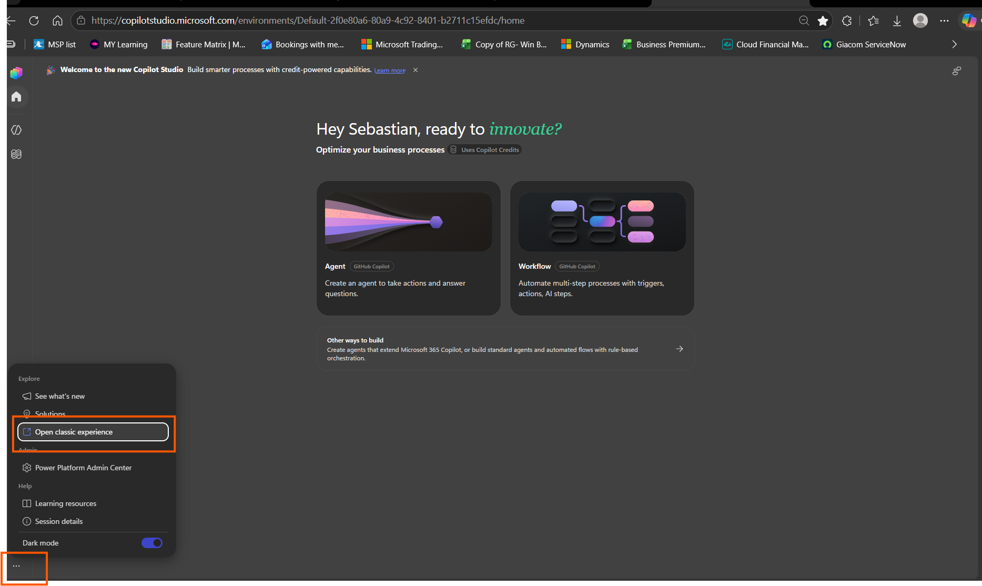

- Head to Agents -> Create blank agent
- Head over to Tools > + New Tool
- Select Excel > Add New Row into a Table
- Add Input Location > Document Library > File > Table
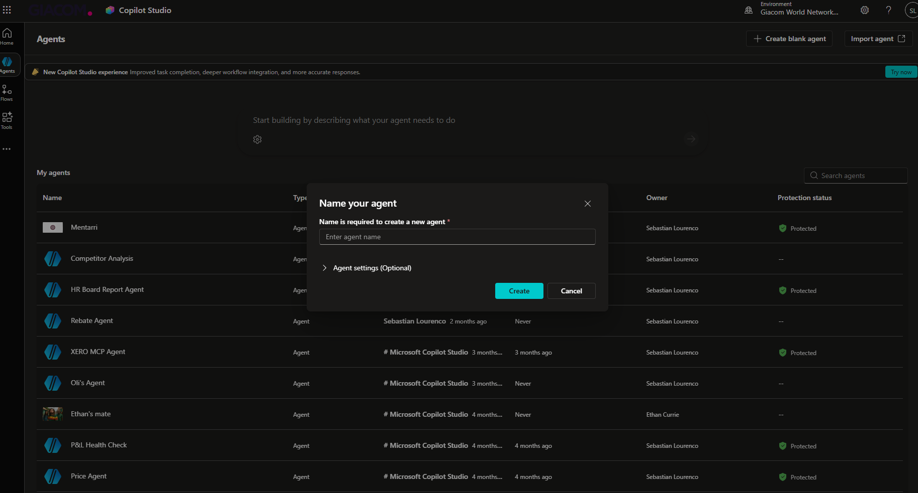
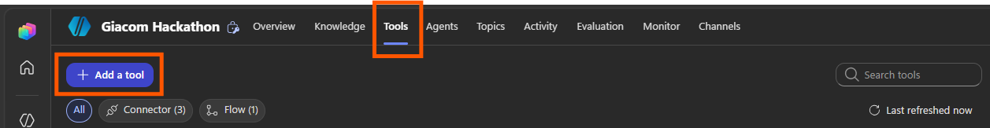
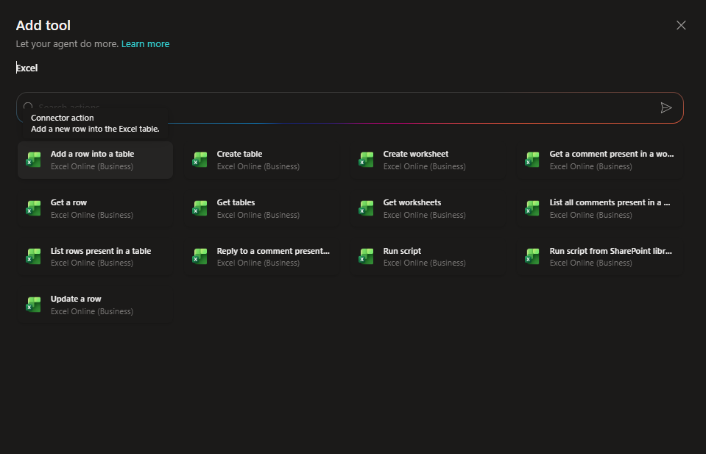
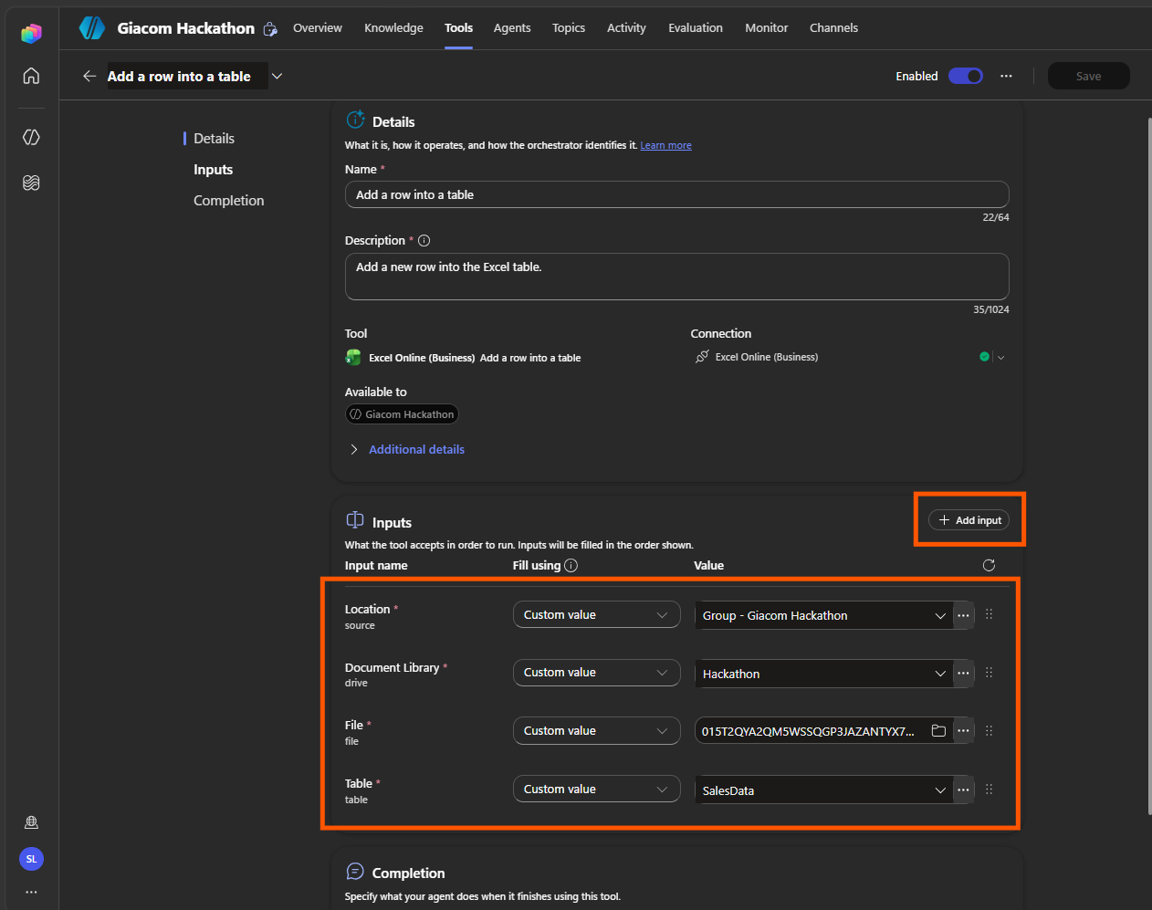

Step 3: Add List rows present in a table & Update a row
- Repeat the same Inputs as Step 2
- Add update a row but leave key column and key value as dynamically fill with AI
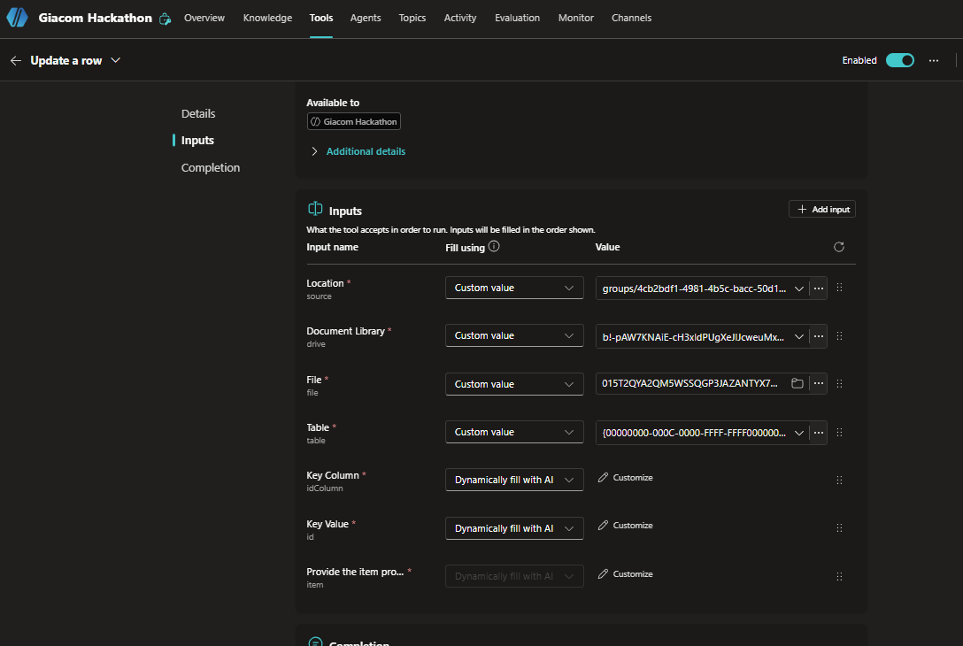

Step 4: Test the Agent
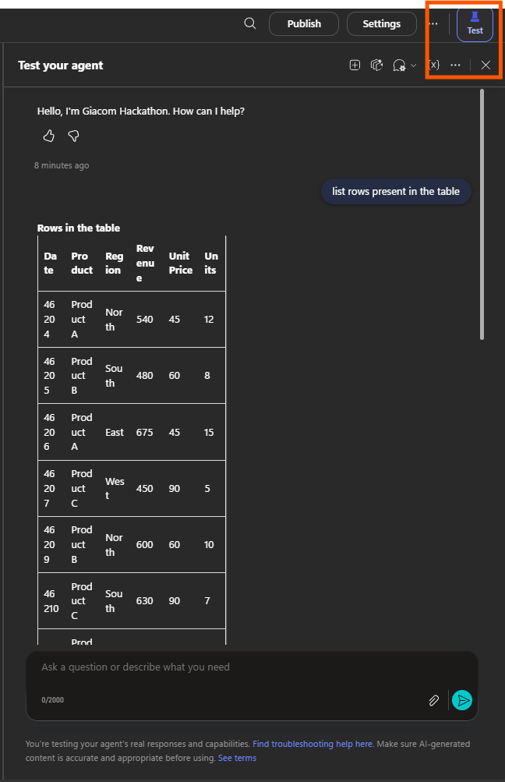
Step 5: Bonus – Add a Topic to process documentation
- Head to Topics Tab and Add a New Topic
- Give it a trigger phrase of “Trigger when the user asks to Upload Documentation” > Add Action Step Ask a Question
- Set Identify as File > set to Global
- Select output twice > Entity Recognition > Include File Meta Data
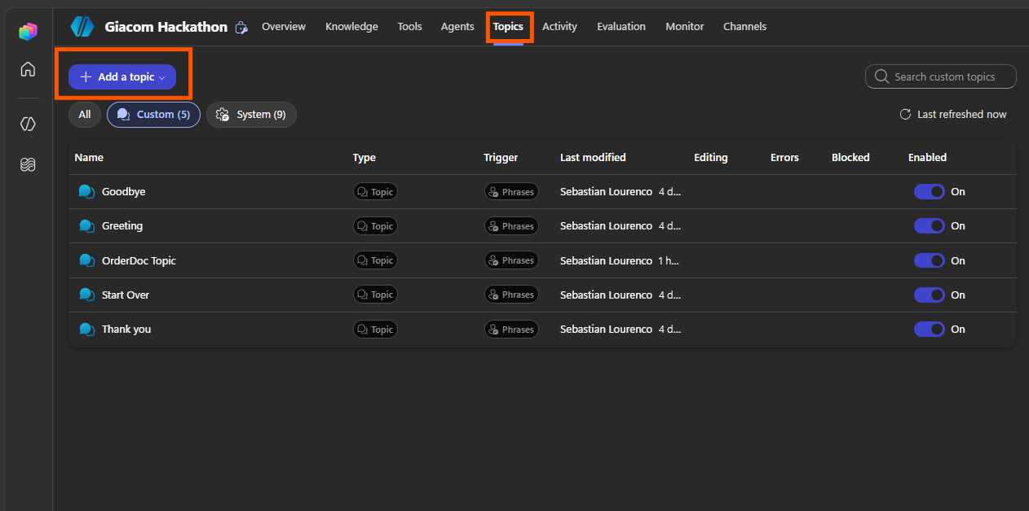
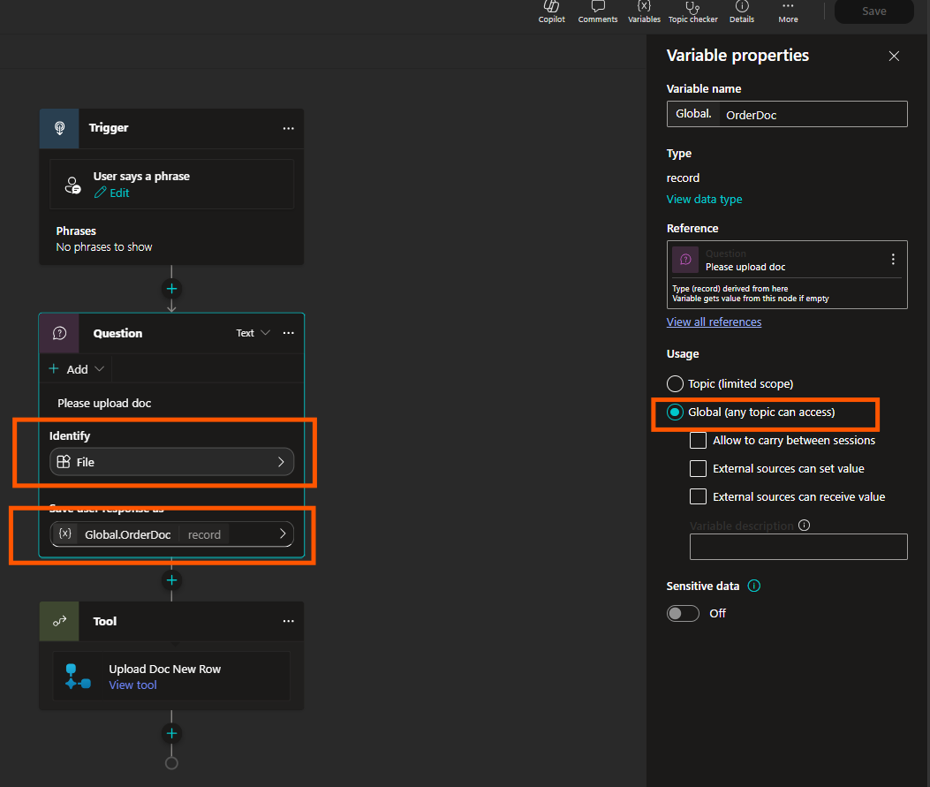
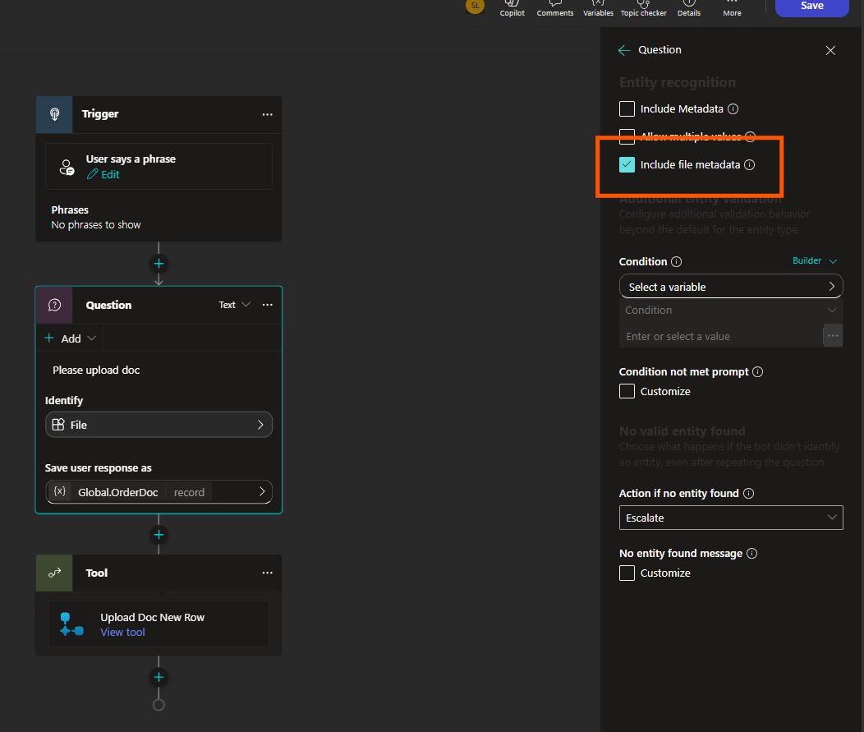

Step 6: Add another Tool
- Add a new Workflow
- Add Input File
- Add a new action Run a Prompt > Set Output to JSON
- Add a new row in a table > Dynamic content > align output from Run a Prompt

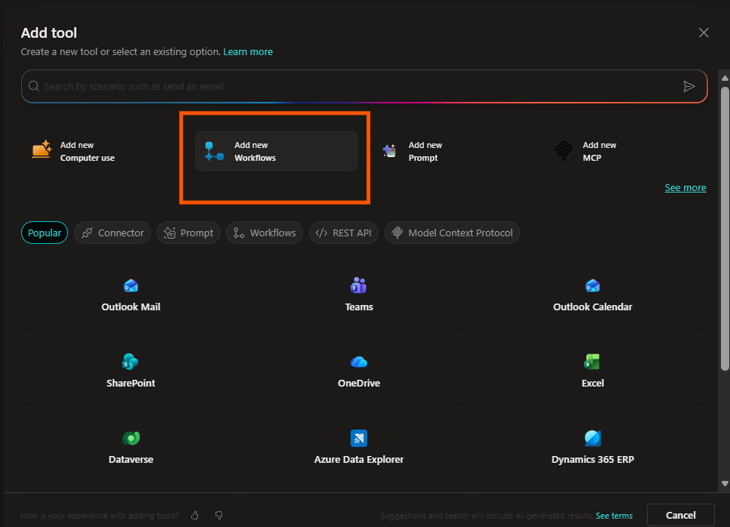
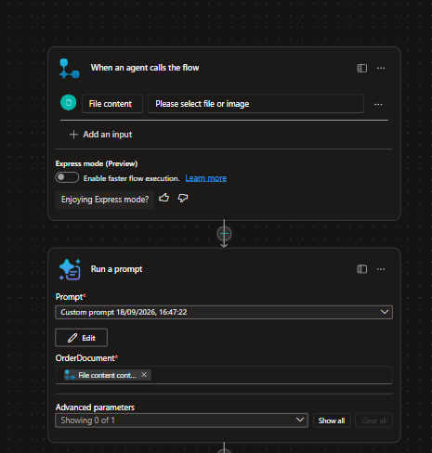
You are extracting a single sales order from an uploaded document (an order
confirmation, invoice, or similar) so it can be added as one row to a sales
tracking table.
Read the document and return the following fields exactly as specified:
- OrderDate: the order date, formatted as yyyy-mm-dd. If the document shows
a written date (e.g. "21 July 2026"), convert it to this format.
- Region: the sales region associated with the order. Must be exactly one
of: North, South, East, West. Infer the closest match if the document
uses different wording (e.g. a delivery city or address), but only choose
from these four values.
- Product: the product ordered. Must be exactly one of: Product A,
Product B, Product C. Match based on the product name or description in
the document.
- Units: the quantity ordered, as a whole number. Do not include currency
symbols or units of measurement.
- UnitPrice: the price per unit, as a plain number with two decimal places
and no currency symbol (e.g. 90.00, not £90.00).
- Revenue: the total line value for the order, as a plain number with two
decimal places and no currency symbol. If a total is not explicitly
stated, calculate it as Units × UnitPrice.
Rules:
- Extract only, never invent. If a field genuinely cannot be found in the
document, return an empty value for that field rather than guessing.
- Do not include currency symbols, commas, or units in any numeric field.
- If the document contains more than one line item, extract only the
first/primary order line.
- Return only the structured fields requested — no extra commentary.
Document to extract from: [Document Input]

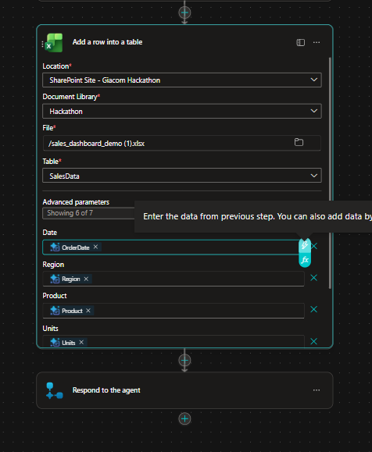

Step 7: Head back into Topics
- Add a new action > Add a tool > add the workflow
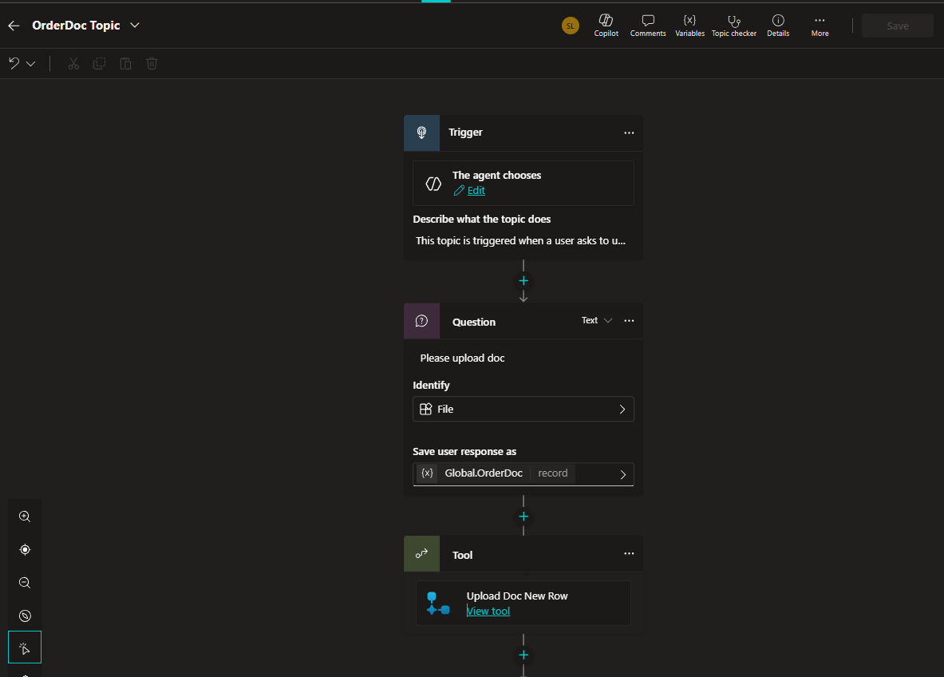

Step 8: go back into the tools tab
- Add 2 inputs > link Global.OrderDoc.Content and Global.OrderDoc.Name
- Test again and the Topic should now run as expected
